2021
l
Portage First Baptist Church
7/29/2021
Come Fellow-Ship Newsletter
COME FELLOW-SHIP
“WE ARE OPEN”
150 May attend Inservice Church, Please wear a mask and hand sanitize and social Distance
Sermons:

August 1-Warren Bracken
August 8th & 15th- Rod Brown
August 22nd& 29th Glenn Cordery

Prayer Gathering
You are Welcome to join us,
Every Tuesday @FBC 10:30 a.m
Join us For Song, Praise and Prayer

Hey Kids!! Summer time is here,
We pray you continue your walk with Jesus.
Don’t get to busy that we miss seeing Jesus at work through other’s this summer keep your eyes open to what God has for you. Ask Holy Spirit to help you.

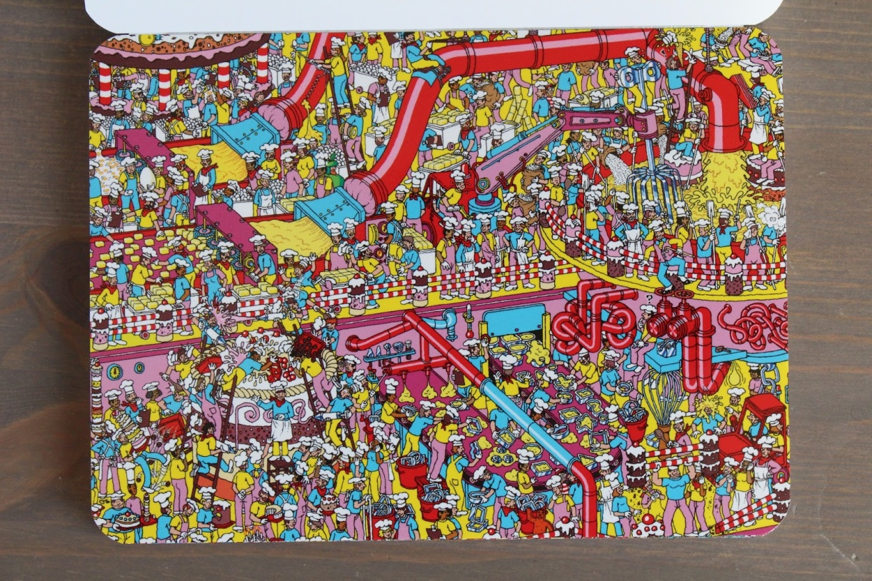
Keep Safe and Keep Reading your Bible and Praying everyday and you will grow

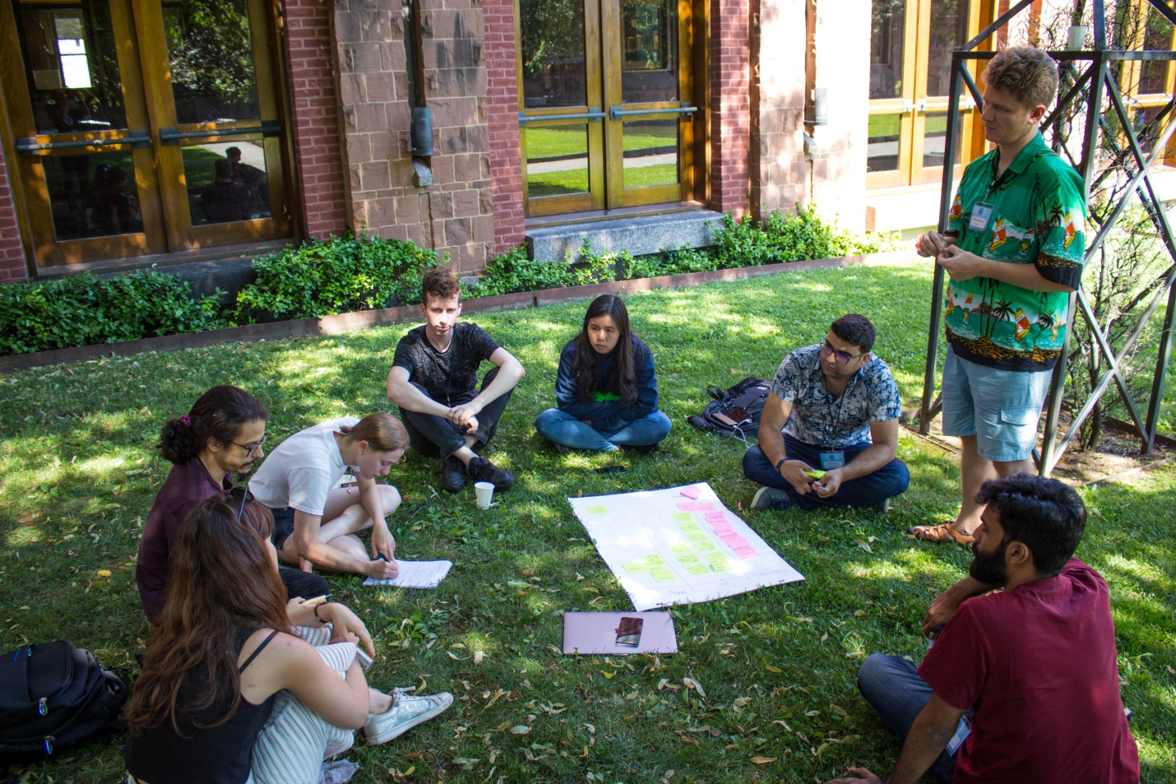
Sermons on YouTube
Click the Link to Listen to Sermons
https://www.youtube.com/channel/UCDhcjr8T-hWm-K4VBg05IZg

I surrender all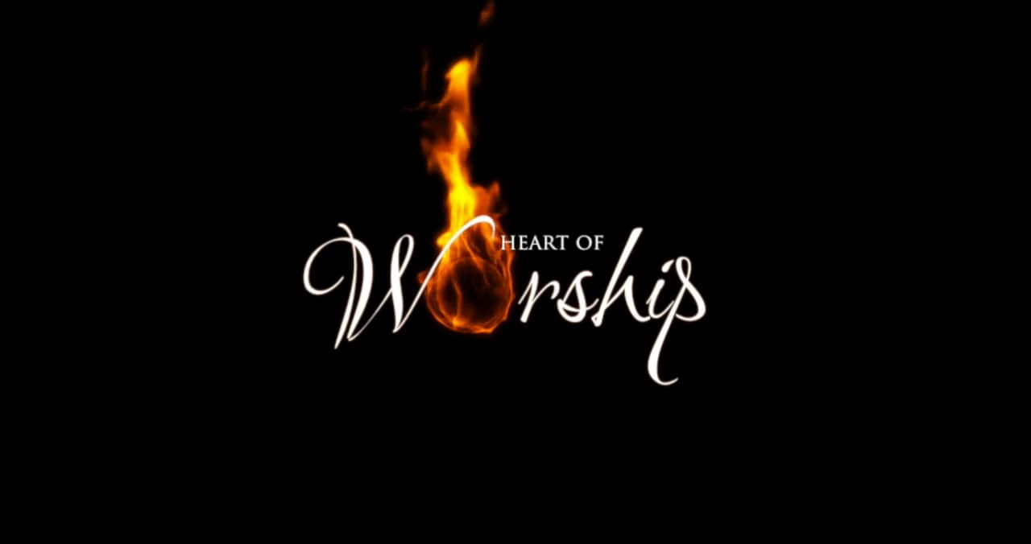

Worship Song to Enjoy this week:
I surrender all
https://www.youtube.com/watch?v=SW8EA7DEQ2M&ab_channel=PraiseAdonai

But Seek ye first the Kingdom of God, and his righteousness; and all these things shall be added unto you
Matthew 6:33

August 2021
Auust 2nd- Shadrack Osifeso- Leora Braden
August 10th- Taylor Carlson- Jyette Johnson
August 16th- Tim Rodgers- Tabitha O
August 17th-Naomi Osifeso
August 24th –Bert Nottingham
August 29th- David Osifeso

Let us know if you have a Birthday!

Let us know if you have anniversary!

Reflection/Meditation
For those who know me well, know that I love Coffee and anything to do with food, but I especially love to enjoy it with others. My Husband and I had holidays and we went not too far away, Close to Riding Mountains, Darryl helped a cousin out on their farm id dauphin, while I and my Cousin went for a ride to Visit a Friend. We enjoyed each other’s company and laughing and talking. Throughout the day I kept getting a strong sense to pray for God to make time for him to in our conversations and had been thinking of others who may not know Jesus. We had so many conversations in one and then all of Sudden My Friend asked the question about other God’s!!! The Friend shared that her and someone else didn’t see eye to eye or ear to ear. But the Lord allowed what was shared to be the same and what God’s word says there shall be no other God’s before me and that there is only one way to heaven. The conversation was richer in person then to try and explain here. The part was God had arranged for us to be there and to be able to share his word and truth with love that we talked and she was open to continue to listen and say that is exactly what she had heard from the person sharing with her. I love moments where God is working and we can listen and tune in and Follow his lead.
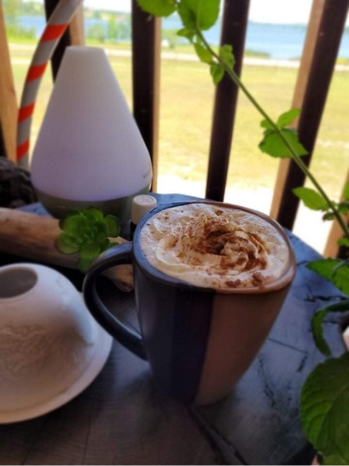
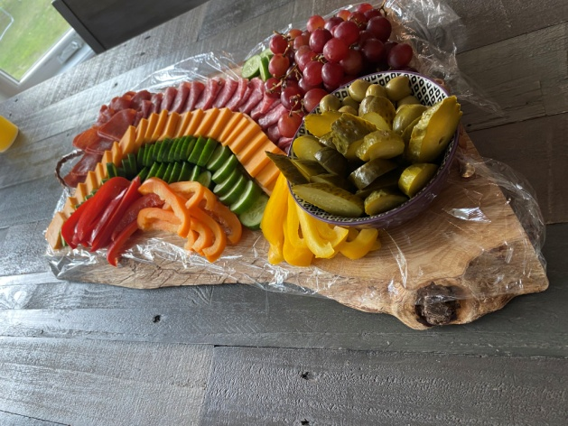

KIDSZONE FOR JESUS
ADVENTURES
Story time:

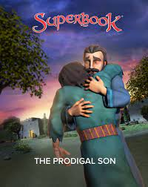
https://us-en.superbook.cbn.com/episode_player?v=4515255877001
Come and Sing, Dance Unto the Lord
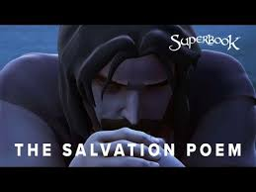

https://us-en.superbook.cbn.com/video/heroes-bible-salvation-poem
Want to Watch more episodes you can register to watch more free episodes https://secure.superbook.cbn.com/join?sl=en&refcode=FEPCZ
Youth and Young Adults!
Let us Pray for you!

We want to Connect and Encourage you and pray for you this Summer
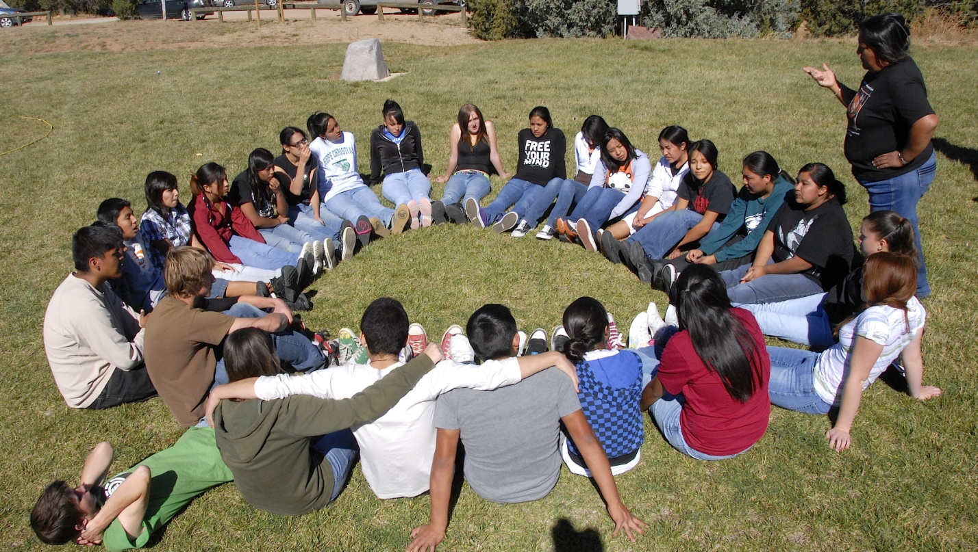

Church Websites:
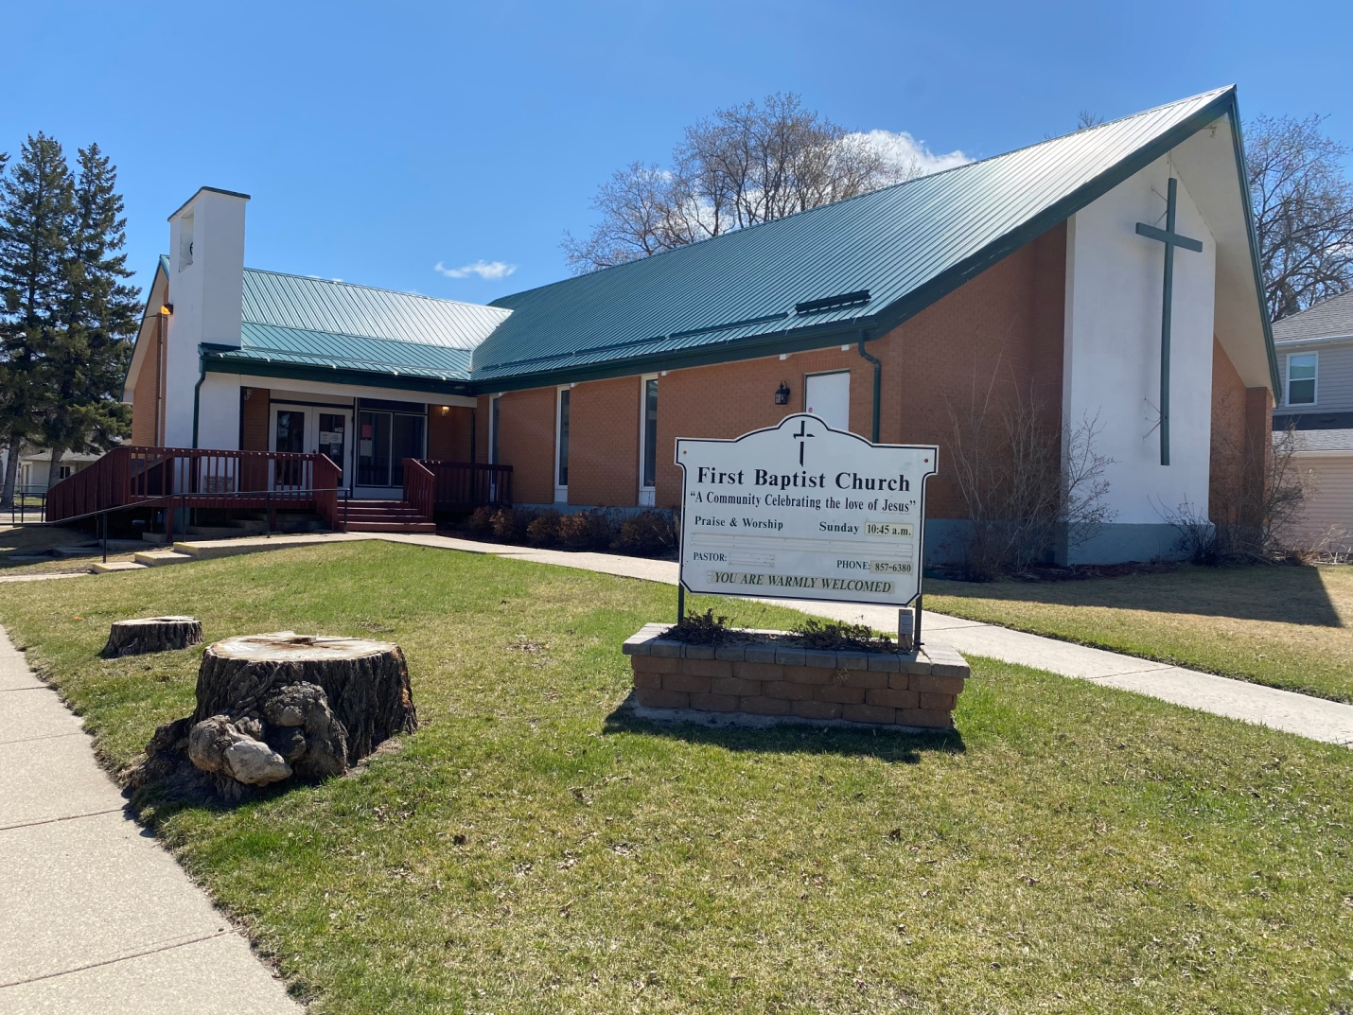

http://www.firstbaptistchurchofplap.com

Facebook:
https://www.facebook.com/firstbaptistchurchofportagelaprairie
YouTube:
https://www.youtube.com/channel/UCDhcjr8T-hWm-K4VBg05IZg

Let me know if you have something you would like to Contribute to the Weekly Newsletter
God Bless,
FBC

Have a Great Weekend, Encouragement and Prayers, for each of you.
” being the Hands and Feet and Heart of Jesus”
He said “Go into all the world and preach the gospel to all creation
Mark 16:15

